优秀教案（是/否）
北京师范大学2015级普通师范生教学实习教案

部院系 外国语言文学学院英语 专业 英语 实习生姓名 郝梓岑 学号 201511100152
部院系指导教师 王广州 实习学校教学指导教师 蒋洁
2018年 10 月 23/24 日 (星期 二/三 ) 第 二 节课 实习成绩 优
（本人本次实习第 二 个教案）

实习学校 | 北大资源中学 |  | 实习班级 |  | 初二3班；初二8班 |  | 实习学科 | 英语
教学课题 | 听说课
所用教材 | 教材名称：义务教育教科书 英语 八年级 上册 第 5 单元 33-34 页  出版社：人民教育出版社
教学目标 | 在本课结束时，学生能够  - 通过听录音，找出并归纳两段谈话中提到的关于电视节目种类的事实性信息，如soap opera, talk show等；（获取信息）  - 归纳和总结对话中的评价词，结合对话内容的框架，形成对“看电视节目”这一事实的结构化知识（电视节目种类和内容，以及谈论不同类型的电视节目的看法与偏好）；（梳理整合）  - 根据获得的信息和语言知识，对听力内容进行总结和复述；（内化应用）  - 运动一些简单的听力策略辅助自己理解内容；（技能培养）  - 通过研究系列影视作品，培养思辨力；培养学生思考合理规划业余时间、屏幕时间使用质量的意识。（情感态度）
教学重点 | 学生能够提取归纳电视节目的种类、表达看法和偏好、把握文字传递的感情色彩，并形成清晰的内容框架；  学生对屏幕时间使用质量有一定了解，形成自己的见解，并能思考如何规划业余时间。
教学难点 | 学生能够结合信息对听力内容进行适当的预测和推测；  学生能够对提取到的信息进行分类整合，形成结构化知识；  学生能在新语境中迁移所学到的信息内容。
课时安排 | 1课时 |  |  | 教学用具 |  | 多媒体设备；黑板；课本
教学方法 | - 创建半真实的语言环境，引导学生在情景中学语言，在学习新的语言知识后，创造性地运用语言；  - 开展多种类型的任务活动，提供给学生合作交流的空间和时间，促进学生为完成任务和同学进行合作，为完成任务进行探究性学习。
教  学  过  程  及  内  容 | 教材分析  学习主题：娱乐活动  语篇特点：日常对话  语言知识：不定式作宾语，有关不同类型电视节目或电影的词汇和常用表达  语言技能：听力理解；听力策略；口语表达与运用  学习策略：认知策略、互动合作  Section A共有两篇听力材料，第一篇听力材料是一篇发生在日常生活中的对话，通过Mark和Jack的问答对话，展示一些电视节目的种类和对它们的评价，访谈依次以“晚上看什么电视节目”，“某个电视节目怎么样”这两个方面展开，结构较为清晰，内容比较简单，适合对课程内容的话题引入。第二篇听力材料较第一篇难度增大，不再是仅仅讨论对电视节目的选择，Sally和Lin Hui开始思考能从节目中学到什么，不同种类的电视节目的意义是什么，使谈话内容更加有深度，与此同时，Sally展开描述了自己对电视节目的需求，能够从电视节目中获得什么，让Lin Hui进行猜测，谈话内容又变得更为活动生动。  该部分两篇听力材料涉及到日常生活中关于电视节目的选择，与生活联系紧密，学生对此话题也很熟悉，有较多生活经验，所以容易激活学生的已有经验，从而引发学生与文本的共鸣，并形成积极的互动。听力材料对于初二的学生来说难度适当，话题主线非常突出，适合训练学生获取、分析和归纳的能力，并根据所获得的信息发表自己的观点和见解，但是同时，文本中的部分细节信息比较分散，尤其在听力训练中，学生对信息的感知不如阅读强烈，这一特点会被放大，从而难以形成清晰深刻的印象，教师需要整合并帮助学生在零散的信息之间建立起意义关联。  同时，这两篇听力材料都涉及了与电视节目相关的生词和词组，以及一些表达评价的表达，教师需要挖掘文本中这些关键点，并在新的语境中迁移所学内容，实现创新表达奠定基础。  学情分析  本节课的教学对象是初二学生。  首先，初二的学生在通过初一的学习后，已经掌握了一定的词汇、语法知识，并具备了一定的表达能力和听力水平，大部分学生能积极探索适合自己学习英语的方法，对语言产生了敏感度。  由于听力内容的科学趣味性是比较容易引起学生共鸣与兴趣的，所以学生的学习动力比较充足，注意力相对集中。同时初二的学生有一定程度的生活常识，乐于表达自己的观点和想法，可以分享的生活中的事例较多且在联系实际上也具备了一定的能力。  但是，该阶段的学生在听说方面依然存在以下问题：首先，学生在接触全新的听力材料时容易产生畏难和恐惧情绪；其次，学生在每一次听时提取信息的广度和深度都有限；另外，学生难以独立充分整合内化信息，并且迁移知识的能力较为不足，需要老师积极引导；最后，初二学生在口头表达上的丰富度和准确度都有一些欠缺。  教学过程 Teaching Procedures  Pre-listening  Step 1 (CW/GW, 3 minutes)  T says hello to class, introduces the survey and asks what kinds of TV shows students would like to watch in their spare time.  T: “Hello, boys and girls. As your practice teacher, I want to know you better. So I am going to do a survey about what kind of TV shows you would like to watch in your spare time.”  Before doing the survey, T invites students to have a simple brainstorm about the types of TV shows.  T: First of all, I am wondering do you know any types of TV shows and can you share in the class?  Students have a brainstorm in their groups and share in class.  Justification:  - 结合实习老师的身份，将学生与实习老师的相处经验与本节课的主题TV shows相结合，让学生迅速参与课堂，且能起到活跃课堂气氛的作用。  - 教师通过设置小调查的方式，一方面激起学生的兴趣，建立课堂真实交流；另一方面通过头脑风暴的互动，调动学生内在已有知识，同时为后面环节中类似的语言输出打好基础。  Step 2 (CW/PW, 5 minutes)  After brainstorming, T gives responses and give further explanation about the types of TV shows.  Types: talk show, soap opera, sports show, sitcom, game show, talent show, reality show, news, fashion show, documentary, commercial, advertisement, variety show, TV serial, weather forecast, cartoon  T would help students understand the definitions of all kinds of TV shows with the aid of pictures, video-clips and specific explanations.  If needed, T should tell the differences between two similar types, such as, A soap opera is usually very long and has many episodes. All the episodes of a soap opera are interconnected. A sitcom, or a situation comedy, is a set of funny stories. These stories all happen in a small place, like a house or a workplace. Sitcoms are different from soap operas. Each story in a sitcom can be a different one and sitcoms make people feel happy.  T asks students to do the survey together and share their answers in class.  When expressing their opinions, students should choose one type of TV show, make a comparison, and talk about their reasons.  Justification:  - 再上一个环节的输入基础上，教师引导学生就自我认知和个人经验对图片呈现出的电视节目种类进行定义，进行简单的生成和输出练习。  - 活跃课堂气氛，使学生畅所欲言，灵活使用图片、小短片等，带领学生基于他们的已知从多角度理解电视节目种类，培养学生的思考能力和表达能力。  - 将听力材料中的新词汇进行输入，扩大学生的词汇准备，扫除一些听力中影响理解的障碍，帮助学生更好地消化听力内容。  - 通过这个环节让学生充分沉浸在“TV shows”的话题背景中。  Step 3 (CW/GW, 2 minutes)  T then introduces the topic of the listening material, and lets students predict the content.  T: “Great, so TV shows are very important in your daily life and very common to all of us. Now we are going to listen to a recording. Two students, Jack and Mark are talking about TV shows. Before that, can you tell me what aspects about TV shows do you expect to hear from the tape?”  Students share their predictions and ideas.  T: “(Give some feedbacks on students’ answers) OK, now let’s listen to the tape and see whether what you hear is the same as what you expects. Also, I want you to number the shows [1-4] in the order you hear them.”  Justification:  - 经过前期铺垫后引出听力内容的主题，鼓励学生大胆预测听力内容，激发学生的好奇心和对“TV shows”的联想性思维，从而能够更快地融入并理解听力材料。  - 明确第一遍听力的任务，让学生带着目的去听材料，主动地获得信息。  While-listening  Step 1 (CW/IW, 4 minutes)  T plays the radio 1st time and students listen.  After listening, T first focuses on the question “what aspects about TV shows are they talking about” and checks the answers with students together.  Then T further asks: “What do Mark and Jack plan to do and how do they like those TV shows?”  T presents the questions on the PowerPoint and encourages students to guess the answers. Students give some assumptions based on the nature of the conversation.  1b Listen again and answer the following questions.  - What does Mark plan to do later?  - What does Jack think of talk shows?  - What does Jack think of talent shows?  - Does Mark want to watch the soccer game at 5:00? How about Jack?  Justification:  - 及时解决听前的问题，并在原有的问题基础上递进，帮助学生建立听力材料中基本要素：人物关系和事件。  - 训练学生的推断力，有助于学生进一步理解听力内容。  - 通过让学生验证自己的推断，激发学生进行第二遍听力的好奇和渴望，同时明确第二遍听力任务，引导学生注意细节信息。  Step 2 (CW/GW/IW, 6 minutes)  T plays the radio 2nd time and students listen.  After listening, students discuss their opinions in groups first and share in the class.  Based on the answers, T asks students, “Which one does Jack like best? Games? Talent shows, or talk shows?”  Jack doesn’t mind talk shows.  Jack can’t stand talent shows.  Jack loves the game.  Students give the answers and make a observation of words filling-in the blanks.  Justification:  - 核对答案，检验学生对信息的提取程度。  - 基于学生自己提取的细节信息，对听力材料中表达情感态度的词汇进行整理，为下一环节中对喜好的讨论做准备。  Step 3 (PW/CW, 3 minutes)  T: “Now, we know Jack’s and Mark’s preferences about TV shows. What about talking about our likes or dislikes?”  T introduces how to talk about preferences.  Questions: What do you think of …? = How do you like…?  Answers: I love/like/don’t mind/don’t like/can’t stand…  Then students can work in pair and practice the conversations.  A: What do you want to watch?  B: What do you think of talk shows?  A: They’re OK. I don’t mind them.  B: Then let’s watch a talk show.  Justification:  - 训练学生的表达能力，学会通过语言文字表达感情色彩。  - 学习相关语言技巧，如能自如询问偏好并进行对应的回答。  Step 4 (CW/IW, 3 minutes)  After conversation-practicing part, T introduces next listening material.  T: “There are also another two girls talking about TV shows. Close your books. Please listen and write down all the TV shows you have heard.”  T plays the radio 1st time and students listen.  After listening, T and students check the answers together.  If students give the complete answer, then T can go to the next part directly. If students miss some types, then T can introduce the next part “let’s listen again and find out all the TV shows they have mentioned”.  Justification:  - 在第一篇听力材料的基础上，自然地迁移至第二篇材料。  - 强化听力训练，通过听力进行内容的输入，为之后的输出做好准备。  Step 5 (CW/IW/GW, 3 minutes)  T: “Let’s turn to 2b, listen again and complete the sentences.”  T plays the radio 2nd time and students listen.  - Sally likes to watch ________________.  - Lin Hui thinks she can learn _____________ from sitcoms.  - Sally thinks ___________ are more educational than sitcoms.  - Sally loves __________. She plans to watch Days of Our Past _______.  - What does Lin Hui think of sitcoms?  Students discuss in the groups and then share their opinions in class.  Justification:  - 训练学生整合细节信息的能力。  - 学生能够对听力材料的内容有更为具体的了解。  Step 6 (GW/IW, 5 minutes)  Based on the nature of the conversation, students try to analyze the listening material and complete the chart.  Students discuss in the groups and make a short report in the class.  Sally and Lin Hui are talking abut some TV shows.  Sally likes… because she thinks that…  But Lin Hui likes…, and she thinks…  As for me, I like… because…  Justification:  - 学生对上面两篇听力材料的内容不断内化，在这一环节通过小采访的方式进行简单输出。  - 在输出内容的同时，学生可以对于如何采访和进行采访问题设计有一定了解，为读后环节中的输出打基础。  Post-reading  Step 1 (CW, 2 minutes)  T asks students to role-play the conversation in 2d. Boys in class play the role of Grace and girls play the role of Sarah.  T: “Besides, there are another two students in class talking about their plans and their preferences about TV shows, let’s role-play the conversation together!”  Justification:  - 学生通过口头朗读的方式，能对对话的内容形成事实性的了解，并找到需要学习和了解的语言表达，进行归类学习。  - 在课程的后半部分教学中，教师通过设置全班角色扮演朗读课文的活动带动学生的有意注意，充分为最后的内容输出打好基础。  Step 2 (IW/CW, 2minutes)  After role-play the conversation, students fill in the blanks according to the conversation and share their answers in class.  Sarah had a discussion about ___________ in class today. Her classmates like ___________ and ___________. But Grace _________ them. She loves __________ because she likes to _______ the story and see what happens next. Sarah __________ them. Her favorite ones are the _________ and ___________, but Grace thinks they’re _________. However, in Sarah’s mind, they may not be very ________, but we can expect to ________ a lot from them. She hopes to be a ____________ one day.  Justification:  - 对上一环节的内容进行简单输出，承接下一部分的内容。  - 利用填空的方式继续带动学生的有意注意。  Step 3 (GW/IW/CW, 2 minutes)  T: “After all, I know some of you do not have enough time with the television in your spare tine. But we do spend much time on our phones or computers, right? So now let’s have a discussion based on the following questions.”  - What activities do you often do with the screen?  - How much time do you often spend on the screen?  - Why do you need the screen?  Students share the opinions in group and make some more conversations after class.  Justification:  - 结合学生自身情况，引入“screen time”，讨论和反思业余时间规划的问题。  - 引导价值思考，升华本节课的价值教育。  Homework: Practice 1b, 2c and 2d and make your own conversations.
   | likes | reason(s) | dislikes
  Sally
  Lin Hui
板  书  设  计 | 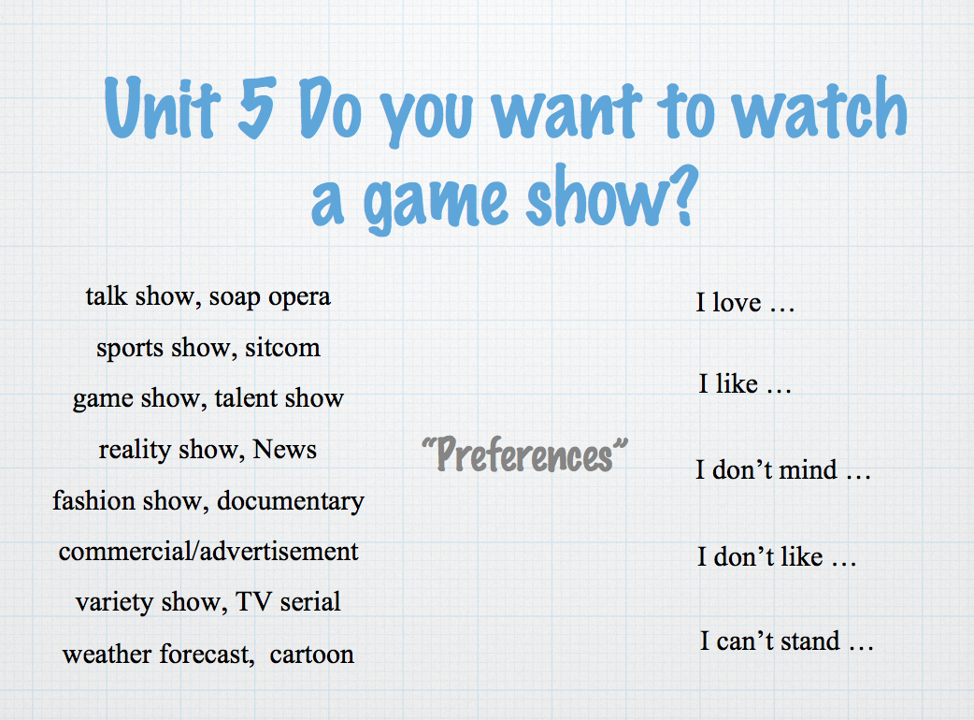
课  后  总  结  与  评  议  记  录 | 自  我  分  析  和  同  学  评  议  意  见 | 该节课教学设计非常巧妙，结合教材特点,学生、教师实际,一法为主,多法配合,优化组合。练习提供了学生喜闻乐见的资料，课堂练习紧扣重点,并注意在“趣”字上下功夫；课堂结构清晰、运用恰当的教学方法和手段启迪学生思维、解决重点、突出难点。根据班级实际情况，精心设计练习，并在整个教学过程中注重因材施教，是一节优秀的课。  签字：___________
课  后  总  结  与  评  议  记  录 | 实  习  学  校  指  导  教  师  意  见 | 本节课对教学内容把握透彻、挖掘深入、处理新颖，在课堂教学中，对重难点言简意赅，分析透彻。对练习以思维训练为核心,落实双基，是一节非常成功的课。此外，该节课十分有创意，教学目的明确，方法得当、语言清晰，具有感染力，习题典型，题量适当，激发学生兴趣，引导自主探究、合作交流完成任务，整个课堂效率非常高。  签字：___________
课  后  总  结  与  评  议  记  录 | 部  院  系  指  导  教  师  意  见 | 表现优异。  签字：_____________

注：1.本表由实习生填写，每实习生不少于四份。每一节新课（或连堂课）填写一份。
2.打印填写后由实习学校教学指导教师和我校的指导教师签字，部院系存档。

